**Object Oriented Programming**

**Lab report: 6**

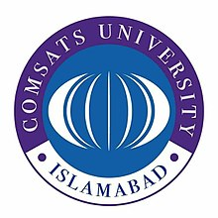

|  |  |
| --- | --- |
| Name | Ali Salman |
| Reg no | FA22-BCE-005 |
| Class | BCE- 4 |
| Instructor’s Name | Prof. Tayyab Rasul |

**Lab 07 – *Inheritance and Overriding***

**Lab Tasks**

**5.1.**

**Program:**

**Classes:**

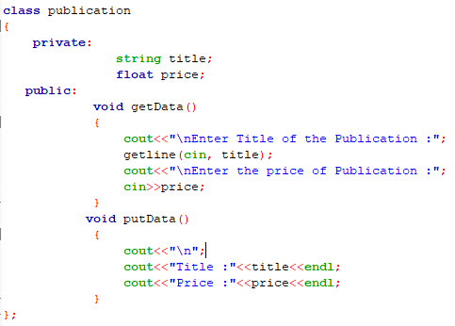

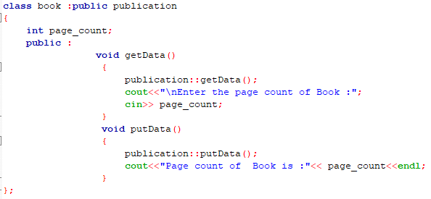

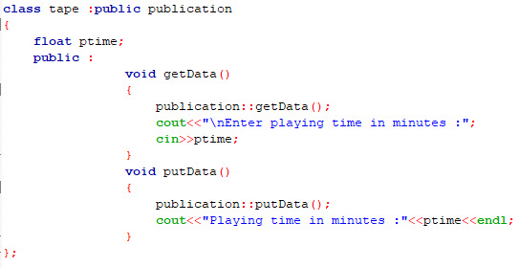

**Main:**

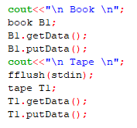

**Output:**

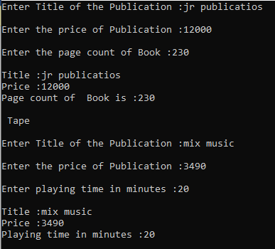

**5.2.**

**Program:**

**Classes:**

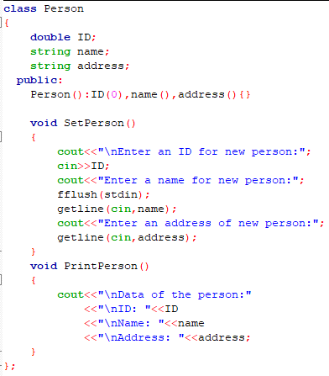

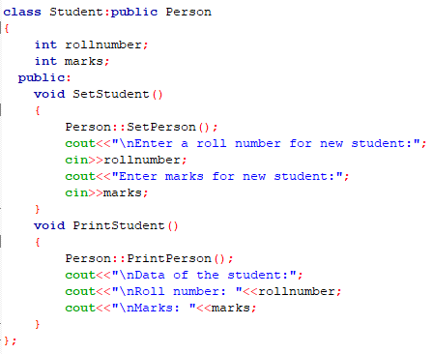

**Main:**

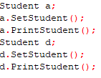

**Output:**

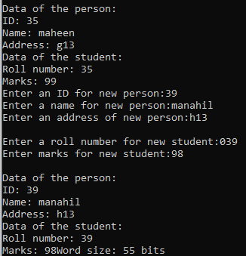

**5.3.**

**Program:**

**Classes:**

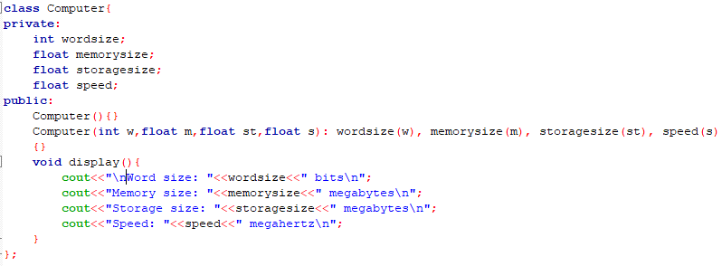

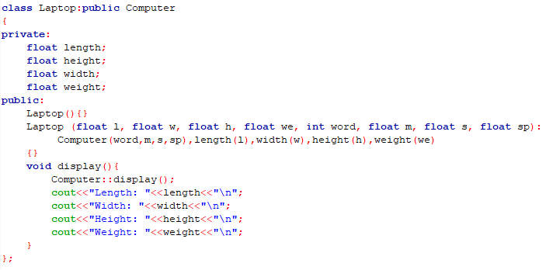

**Main:**



**Output:**

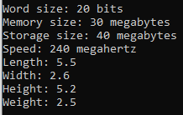

**Home Task:**

**6.1.**

**Program:**

**Classes:**

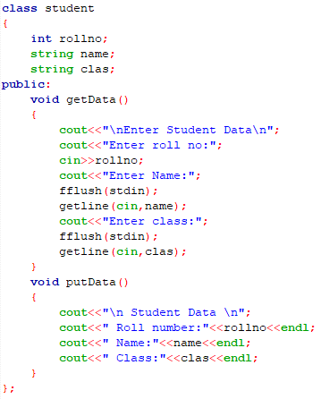

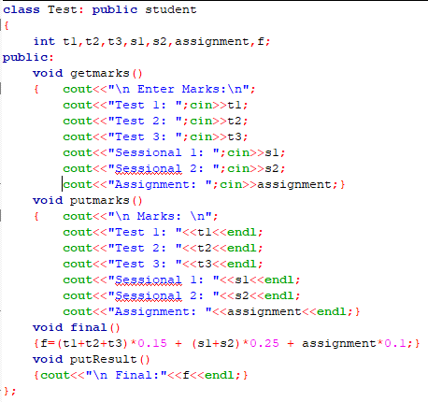

**Main:**

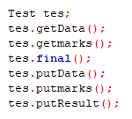

**Output:**

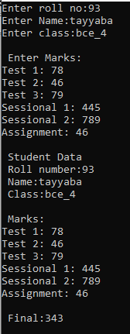

**6.2.**

**Program:**

**Classes:**

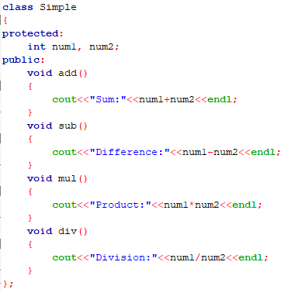

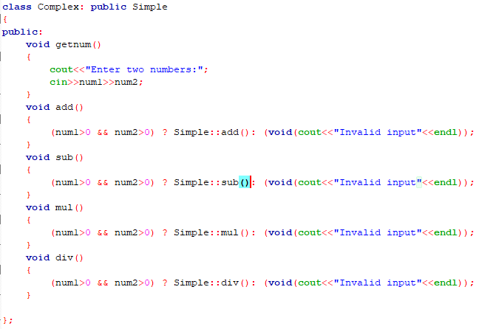

**Main:**

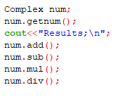

**Output:**

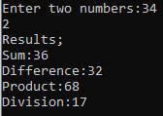

**6.3.**

**Program:**

**Classes:**

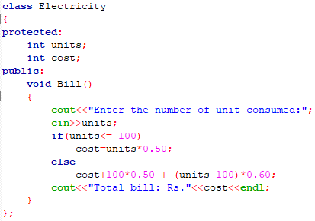

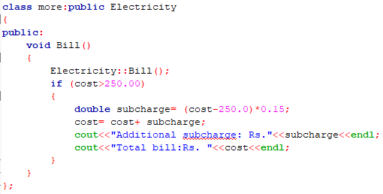

**Main:**

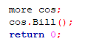

**Output:**

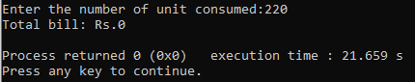

**Critical analysis:**

The lab tasks involving inheritance and overriding in object-oriented programming with C++ are designed to provide students with hands-on experience and deepen their understanding of these crucial concepts. Inheritance allows the creation of a hierarchy of classes, promoting code reusability and extensibility, while overriding enables the modification of behavior in derived classes. However, upon closer examination, several areas of improvement and potential pitfalls can be identified in these lab tasks. This critical analysis aims to shed light on these aspects and offer suggestions for enhancing the learning experience.